-Prepare
You have to provide me Airbnb API and ChatGPT API.

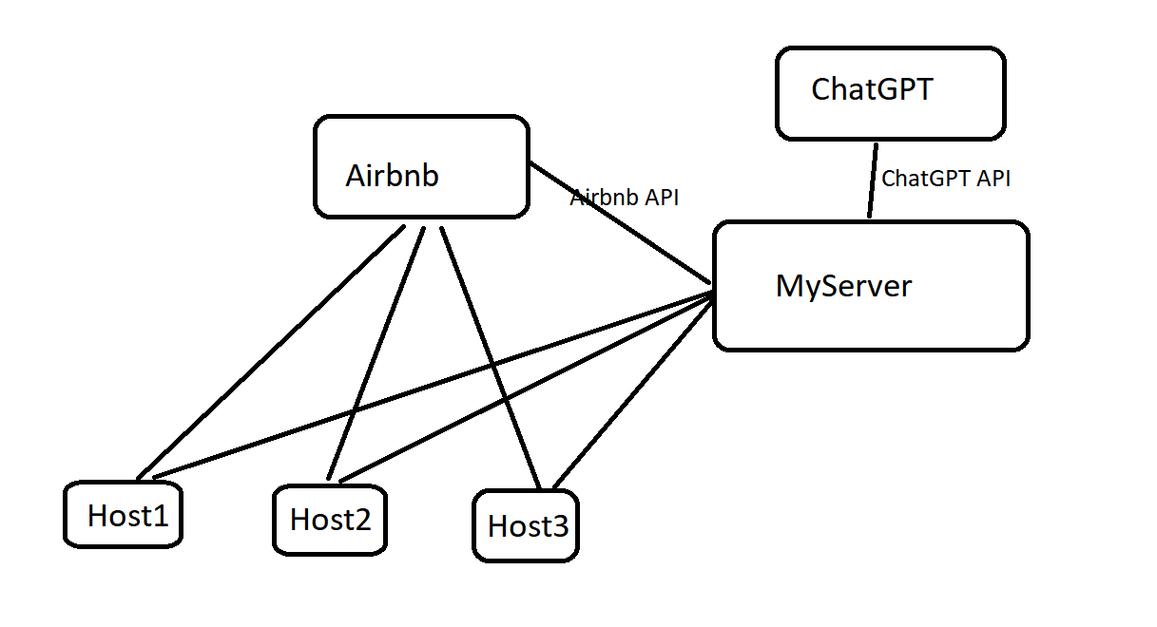
-Dev environment
I prefer MERN Stack
-GPT Integration
By using GPT API Key, i can access this server.
In this , I can use optimization access method(without rate limit error)
I have experience of solving problems. https://github.com/lucalysoft/GPTs
timeline 2days
-Communication with hosts
By using API Key of Airbnb, i can access “contact host”.
Defeat capcha problem.
timeline 2days
-Communication threads
There are many thread in our systems.
Between hosts and our server, between our server and GPT server
Between our server and Airbnb server
timeline 3 days.
-Realtime display
You can check all process at any time.
timeline 1 day
-Proxy support
To avoid rate limit, I need several API keys. If use same API key, Airbnb detect our transaction as DDOS attack.
-Dispatch and delivery
Through all tests of system functions, I will check this system.
I will provide you all documents.

In all I can provide complet system in 10 days.

